|  |  |  |
| --- | --- | --- |
|  | | |
|  | **Nitte Meenakshi Institute of Technology**  An Autonomous Institution under VTU, Belagavi  PB No. 6429, Yelahanka, Bangalore 560-064, Karnataka, India |  |
| **Project Report**  **on**  **“Development of Bitcoin Price Predictor Using LSTM Neural Networks”**  ***A Dissertation submitted in partial fulfillment of the requirements for the award of degree of***  **MASTER OF COMPUTER APPLICATIONS**  **Of**  **Visvesvaraya Technological University (VTU)**  **VTU-logo**  **By**  **SANJAY M**  **1NT22MC091**  **Under the Guidance of**  **Dr. Dileep M R**  **Associate Professor**  **JULY 2024** | | |

|  |  |  |  |
| --- | --- | --- | --- |
|  | **Nitte Meenakshi Institute of Technology**  An Autonomous Institution under VTU, Belagavi  PB No. 6429, Yelahanka, Bangalore 560-064, Karnataka, India | |  |
| **Project Report**  **on**  **“Development of Bitcoin Price Predictor Using LSTM Neural Networks”**  ***A Dissertation submitted in partial fulfillment of the requirements for the award of degree of***  **MASTER OF COMPUTER APPLICATIONS**  **Of**  **Visvesvaraya Technological University (VTU)**  **VTU-logo**  **Submitted By**  **SANJAY M**  **1NT22MC091**  Under the guidance of | | | |
| **Internal Guide**  **Dr. Dileep M R**  Associate Professor  Department of MCA  NMIT, Bengaluru | | **External Guide**  **Sateeshkumar Ambesange**  CEO & MD  B5033, DLF Westend Heights,  Akshay Nagar, Bengaluru - 560076. | |
| **JULY 2024** | | | |

|  |  |
| --- | --- |
| **Nitte Meenakshi Institute of Technology**  **Yelahanka, Bengaluru- 560064**  **Department of Master of Computer Applications** | |
| **CERTIFICATE**  *This is to certify that* ***Sanjay M*** *bearing USN* ***1NT22MC091*** *has completed his final semester project work entitled* ***“*Development of Bitcoin Price Predictor Using LSTM Neural Networks*”*** *as a partial fulfilment for the award of Master of Computer Applications degree, during the academic year 2023-2024 under our supervision.* | |
| **Signature of Internal Guide**  Dr. Dileep M R  Associate Professor  NMIT, Bengaluru | **Signature of External Guide**  Sateeshkumar Ambesange  CEO & MD  Pragyan SmartAI Technology LLP |
| **Signature of HOD**  Dr. Sreekanth R.  Prof & Head, Dept. of MCA  NMIT, Bengaluru | **Signature of Principal**  Dr. H.C. Nagaraj  NMIT, Bengaluru |
| *Submitted to the Department of Master of Computer Applications, Nitte Meenakshi Institute of Technology, for the Viva Voce held on ____________* | |
| **INTERNAL EXAMINER** | **EXTERNAL EXAMINER** |

**ACKNOWLEDGEMENT**

The satisfaction that accompanies the successful completion of any task would be incomplete without mentioning the people who made it possible. With deep gratitude, I acknowledge all those whose guidance and encouragement served as a beacon of light and crowned my efforts with success. I thank each one of them for their valuable support.

I would like to thank **Pragyan SmartAI Technology LLP** for providing me an opportunity to work as an Intern and **Sateeshkumar Ambesange** for his timely support and guidance during my internship period.

I express my thanks to, **Dr. H. C. Nagaraj, Principal, NMIT**, Bengaluru, for all the support and encouragement during my Post Graduate Studies.

I express my sincere thanks to **Dr. Sreekanth R.**, **Professor & HOD-MCA, NMIT,** Bengaluru, whose constant encouragement, guidance and support that has helped me complete the project work successfully on time.

I express my sincere thanks to my Internal Guide, **Dr. Dileep M R, Associate Professor, Department of MCA, NMIT,** Bengaluru, whose constant encouragement, guidance and support that has helped me complete the project work successfully on time.

My special thanks to all the teaching faculty members for providing me invaluable support and guidance.

Finally, I thank my Parents and Friends who have helped me in all possible ways for the success of this project work.

SANJAY M

1NT22MC091

**DECLARATION**

I, **Sanjay M**, student of IV Semester of MCA, **Nitte Meenakshi Institute of Technology**, Bengaluru, bearing USN **1NT22MC091,** hereby declare that the that the project entitled “**Development of Bitcoin Price Predictor Using LSTM Neural Networks”**  has been carried out by me under the supervision of External Guide, **Sateeshkumar Ambesange, CEO & MD** and Internal Guide **Dr. Dileep M R Associate Professor,** and submitted in partial fulfillment of the requirements for the award of the Degree of **Master of Computer Applications** by the **Visvesvaraya Technological University** during the academic year **2023 - 2024**. This report has not been submitted to some other Organization/University for any award of degree or certificate.

Place: Bengaluru Sanjay M

Date: 1NT22MC091

**ABSTRACT**

Predicting Bitcoin prices has become a crucial task for investors and traders due to the cryptocurrency's high volatility. This project investigates the use of Long Short-Term Memory (LSTM) neural networks to forecast Bitcoin prices. Leveraging historical data, which includes opening, closing, high, and low prices, the model aims to identify and learn patterns within the time series data. The data is pre-processed using normalization to enhance model performance. The LSTM model is built and trained, and its performance is evaluated using metrics such as Mean Squared Error (MSE) and Mean Absolute Error (MAE). The predictions are displayed via an interactive Streamlit application, which allows users to upload their datasets, visualize historical trends, and view future price forecasts. The interactive interface enhances user engagement and offers practical insights into potential market movements. The results indicate that LSTM networks can effectively model and predict Bitcoin price trends, offering a valuable tool for making informed investment decisions. This project highlights the significant role of advanced machine learning techniques in financial market analysis and underscores the importance of robust predictive models in managing cryptocurrency investments.

**TABLE OF CONTENTS**

|  |  |  |
| --- | --- | --- |
| **CHAPTER** | **TITLE** | **PAGE NO** |
|  | **CERTIFICATE** | i. |
|  | **ACKNOWLEDGEMENT** | ii. |
|  | **DECLARATION** | iii. |
|  | **ABSTRACT** | iv. |
|  | **LIST OF FIGURES** | v. |
| **1.** | **INTRODUCTION** |  |
|  | 1.1. Statement of the Problem | 1 |
|  | 1.2. Objectives | 2 |
|  | 1.3. Scope | 3 |
| **2.** | **ORGANIZATION OVERVIEW** | 4 |
| **3.** | **LITERATURE REVIEW** |  |
|  | 3.1. Existing System | 5 |
|  | 3.1.1. Disadvantages | 7 |
|  | 3.2. Proposed System | 8 |
|  | 3.2.1. Advantages | 8 |
|  | 3.3. Tools and Technologies used | 9 |
| **4.** | **SYSTEM REQUIREMENTS** | 11 |
| **5.** | **DATA COLLECTION AND PREPARATION** |  |
|  | 5.1. Data Sources | 12 |
|  | 5.2. Data Profile | 13 |
|  | 5.3. Data Cleaning and Preprocessing | 14 |
|  | 5.4 Exploratory Data Analysis | 16 |
|  | 5.4.1. Data Overview | 17 |
|  | 5.4.2. Data Visualization and Insights | 18 |
| **6.** | **METHODOLOGY** |  |
|  | 6.1. Data Analytics | 19 |
|  | 6.2, **Long Short-Term Memory (LSTM)** | 19 |
|  | 6.3. Model Details | 22 |
|  | 6.3.1. Mathematical Background | 22 |
|  | 6.4. Model Training and Compilation | 24 |
| **7.** | **MODEL EVALUATION** |  |
|  | 7.1. Future Price Prediction with Model | 30 |
|  | 7.2. Future Prediction | 31 |
|  | 7.3 Saving the Model | 31 |
| **8.** | **SYSTEM DESIGN** |  |
|  | 7.1. System Architecture | 32 |
|  | 7.2. Flow Diagrams | 33 |
| **8.** | **DEPLOYMENT & STREAMLIT INTEGRATION** | 34 |
| **9.** | **SAMPLE SCREENSHOTS** | 36 |
| **10.** | **CONCLUSION** | 39 |
| **11.** | **FUTURE ENHANCEMENT** | 40 |
|  | **APPENDIX A BIBLIOGRAPHY** | 41 |
|  | **APPENDIX B USER MANUAL** | 42 |
|  | **APPENDIX C PLAGIARISM CHECK** | 45 |

**LIST OF FIGURES**

|  |  |  |
| --- | --- | --- |
| **Figure No.** | **Description** | **Page No.** |
| 5.4.3. | Data visualization | 18 |
| 6.2.1. | LSTM Architecture | 20 |
| 6.3.2. | Project Model Code | 23 |
| 6.3.3. | Model Summery | 23 |
| 6.4.4. | Model Training (Epochs) | 26 |
| 6.4.5. | Training Loss Over Epochs | 26 |
| 6.4.6. | Actual VS Predictions | 27 |
| 7.2. | Future Prediction | 29 |
| 8.1. | System Architecture | 31 |
| 8,2. | Flow Chart | 32 |
| 10.1. | Output 1 | 35 |
| 10.2. | Output 2 | 35 |
| 10.3. | Output 3 | 36 |
| 10.4. | Output 4 | 36 |
| 10.5. | Output 5 | 37 |

**1. INTRODUCTION**

Bitcoin, the pioneering cryptocurrency, has become a significant asset in the global financial market since its inception in 2009. Recognised for being decentralised and resistance to traditional financial controls, Bitcoin has gained widespread popularity and adoption. However, one of the most notable characteristics of Bitcoin is its price volatility, which presents both opportunities and challenges for investors and traders. The unpredictable fluctuations in Bitcoin prices make it a highly speculative investment, necessitating robust predictive models to aid in decision-making.

The objective of this undertaking is to develop a predictive model using Long Short-Term Memory (LSTM) neural networks to forecast Bitcoin prices. LSTM networks, a specific kind of RNN (recurrent neural network), are particularly well-suited for predicting time series tasks because of their capacity to capture long-term dependencies and patterns in sequential data. By leveraging historical Bitcoin price data, including opening, closing, high, and low prices, the model aims to learn and predict future price movements accurately.

The methodology entails a number of crucial procedures. Initially, the historical data is pre-processed and normalized to make certain that the features are scaled appropriately for the LSTM model. The data is then split into testing and training sets to assess the effectiveness of the model. The LSTM model is constructed with several levels, including dropout layers to prevent overfitting. The training data is used to train the model. and its performance is assessed using metrics such as MSE (mean squared error) and Error total mean (MAE).

To make the model's predictions accessible and user-friendly, an interactive Streamlit application is developed. This application allows users to upload their datasets, visualize historical price trends, and generate future price predictions. The integration of a user interface enhances the practical utility of the model, providing a valuable tool for investors and traders to make informed decisions based on the predicted price trends.

This project emphasises the value of cutting-edge machine learning methods in financial market analysis. By utilizing LSTM networks, the model demonstrates significant potential in predicting Bitcoin price trends, contributing to more informed investment strategies in the volatile cryptocurrency market.

* 1. **Statement of the Problem:**

Predicting prices in the cryptocurrency market is difficult due to its extreme volatility, especially with regard to Bitcoin. The intricate, nonlinear price patterns of bitcoin are often beyond the capabilities of conventional financial models. This project's objective is to use past data to create an accurate prediction model for Bitcoin values. Long Term Dependencies in the Data will be captured by the model Using Long Short-Term Memory (LSTM) neural networks. Users will additionally be capable of contribute datasets, view future price projections, and visualize past trends using an interactive Streamlit application. In order to guarantee reliability, the project will evaluate the performance of the model using measures such as Mean Absolute Error (MAE) and Mean Squared Error (MSE).

**1.2. Objectives:**

Our Primary Objectives are:

* **Build a Predictive Model:** Using historical data, build an sophisticated model for machine learning that Long Short-Term Memory (LSTM) is utilised. neural networks to forecast future Bitcoin prices with accuracy.
* **Data Preprocessing and Analysis:** To guarantee the accuracy and integrity of the historical Bitcoin price information utilised to train the model, conduct comprehensive data preprocessing and analysis.
* **Capture Complex Patterns:** Create a model that can successfully represent long-term dependencies and complex, nonlinear patterns in changes in the price of bitcoin.
* **Interactive Visualisation:** Create an interactive application for Streamlit that enables users to see pricing projections for the future, visualise past price trends, and add their own datasets.
* **Performance Evaluation:** To guarantee the precision and dependability of the predictions, assess the predictive model's performance using common measures such as Mean Absolute Error (MAE) and Mean Squared Error (MSE).
* **Usability and Accessibility:** Make sure the software is simple to use and available to both novice and seasoned bitcoin traders, offering insightful information for wise investing choices.
* **Continuous Improvement:** To guarantee that the model remains accurate and relevant over time, create a structure for ongoing model updating and improvement as fresh information becomes accessible.

**1.3. Scope:**

* **Data Collection and Preprocessing:** The project will involve collecting historical Bitcoin price data, including opening, closing, high, and low prices. The data will be cleaned, processed, and prepared for use in the predictive model.
* **Model Development:** Using Long Short-Term Memory (LSTM) neural networks, the project will focus on developing a strong forecasting model that can accurately forecast future Bitcoin prices. The model will be trained on historical data and fine-tuned to capture long-term dependencies and complex patterns.
* **Implementation of a Streamlit Application:** The project includes the development of an interactive Streamlit application. Using this software, users will be able to upload their datasets, visualize historical trends through various charts and graphs, and view future price predictions generated by the model.
* **Visualization and User Interaction:** The application will provide a range a variety of visualisation choices, such as line charts, bar graphs, and interactive plots, enabling users to explore the data and predictions effectively. Users can customize the number of future days for predictions and view results in an intuitive and user-friendly interface.
* **Performance Evaluation:** The predictive model will be evaluated using metrics such as Mean Squared Error (MSE) and Mean Absolute Error (MAE) to assess its accuracy and reliability. These evaluations will ensure the model's predictions are trustworthy and useful for decision-making.
* **Documentation and Reporting:** The project will include comprehensive documentation detailing the methodology, data preprocessing steps, creation of models and assessment of their performance. A final report will summarize the findings, conclusions, and potential areas for future work.
* **Scalability and Future Improvements:** The project will establish a framework for continuous improvement, allowing the model to receive updates regarding new data over time. This scalability ensures the model remains relevant and accurate as market conditions and data evolve. Additionally, the project may explore incorporating other cryptocurrencies and expanding the scope to broader financial markets.
* **Educational Component:** The project will serve as an educational tool for individuals interested in machine learning, data science, and cryptocurrency trading, providing insights into the application of LSTM neural networks in financial forecasting.

**2. ORGANIZATION OVERVIEW**

Founded and run by CEO Sateeshkumar Ambesange, Pragyan SmartAI Technology LLP is a leading training facility with a focus on machine learning (ML) and artificial intelligence (AI). Pragyan SmartAI Technology LLP, located in a bustling urban environment, is committed to providing professionals and students with state-of-the-art knowledge in developing technologies. The organization's goal is to close the gap between industrial demands and academic learning by providing comprehensive programs that integrate theoretical knowledge with real-world applications. Pragyan SmartAI Technology LLP guarantees a high calibre of instruction and mentoring thanks to its cutting-edge facilities and faculty, which includes experienced academics and professionals from relevant industries.   
  
The curriculum of Pragyan SmartAI Technology LLP places a strong emphasis on experiential learning through in-depth projects and workshops, equipping students to tackle real-world AI and ML difficulties. Students get comprehensive the expertise required for success in the workplace, ranging from fundamental ideas to cutting-edge methods like deep learning and natural language processing. In addition to teaching, PragyanAI creates a networking and innovative atmosphere for students, mentors, and business executives. The centre is dedicated to research and development, and through conferences, publications, industrial partnerships, and other means, it actively contributes to the breakthroughs in AI.   
  
Pragyan SmartAI Technology LLP, led by Sateeshkumar Ambesange, is dedicated to providing high-quality AI education and enabling individuals and organisations to use AI for innovative and beneficial projects that benefit society as a whole.

**3. LITERATURE REVIEW**

**3.1. Existing System:**

Financial forecasting is a field that has been the focus of many methodologies and systems, especially for volatile assets like Bitcoin. Machine learning and deep learning models strategies, and conventional statistical techniques that might be employed to broadly classify the systems now in use for forecasting the price of bitcoin.

**• Conventional Approaches to Statistics**

For time series forecasting, conventional statistical techniques like autoregressive integrated moving average (ARIMA) have been widely utilized. ARIMA models use autocorrelation and trend analysis to forecast future values based on historical price data. These models, albeit easily comprehensible and straightforward, frequently fail to adequately represent the highly volatile and non-linear character of Bitcoin pricing.

* **Machine Learning Techniques**

The capacity Several algorithms for machine learning to handle bigger datasets and recognise complex patterns has resulted in their increasing popularity. For predicting the price of Bitcoin, techniques like as gradient boosting, random forests, and support vector machines (SVM) have been used. The long-term dependencies present in data time series may still be difficult for these approaches to handle, but they can model non-linear relationships more accurately than more conventional statistical techniques.

**Support Vector Machines (SVM):** Regression challenges including the prediction of Bitcoin prices have been handled by SVMs. Their goal is to identify the best hyperplane that reduces the amount of prediction mistakes. SVMs, however, may not function well with very large datasets and can be computationally demanding.

**Random Forests and Gradient Boosting:** To increase prediction accuracy, these ensemble approaches merge several decision trees. In contrast to gradient boosting, which constructs trees sequentially to remedy faults from earlier trees, random forests prevent overfitting by averaging numerous trees. They might not accurately depict the temporal connections in sequential data, such as Bitcoin prices, despite their resilience.

* **Deep Learning Models**

Forecasting time series has been transformed by the development of deep learning. Long Short-Term Memory (LSTM) networks, in particular, are recurrent neural networks (RNNs) that have shown a lot of promise in Bitcoin price prediction. LSTM Networks are the best option for forecasting financial time series because of their ability to retain long-term dependencies and minimize the vanishing gradient issue.

**Recurrent Neural Networks (RNNs):** By keeping track of a hidden state that contains data from earlier time steps, RNNs is capable of simulating sequential data. Unfortunately, the vanishing gradient issue plagues ordinary RNNs, making it difficult for them to understand long-term dependencies.

**Long Short-Term Memory (LSTM) Networks:** Memory cells used in LSTM networks have the capacity to store data for extended periods of time, which helps them overcome the limits of ordinary RNNs. Because of this, LSTMs are incredibly useful for modelling temporal dependencies in data related to Bitcoin prices. Research has shown that when it comes to predicting Bitcoin prices, LSTMs perform better than other machine learning approaches and conventional statistical methods.

* **Hybrid Models**

New developments have also investigated hybrid models, which combine various methods to improve forecast accuracy. For example, combining ARIMA and LSTM networks makes use of both techniques' advantages: LSTMs manage volatility and non-linear dependencies, while ARIMA records linear trends and seasonality.

**ARIMA-LSTM Hybrid Models:** To model and exclude linear components from the data, these models initially employ ARIMA. Next, LSTM networks are employed to model the residuals, which capture non-linearities. Both linear and non-linear trends in Bitcoin price patterns have been better captured by this method.

.

**Wavelet Transforms with LSTM:** Wavelet transforms is able to separate time series data into different frequency elements, which are subsequently used as inputs for LSTM networks. This

method enhances The capacity of the model to capture both short-term and long-term patterns in Bitcoin prices.

**3.1.1. Disadvantages:**

* **High Computational Cost:**

Justification: Particularly when training deep learning models those that use LSTM networks, demands a large amount of processing power. Large quantities of RAM and potent GPUs are examples of this, which can be expensive and out of reach for lone researchers or small groups.   
Impact: Deploying these models in real-time applications may not be feasible due to high computational needs, which can also result in higher costs and longer training durations.

* **Overfitting:**

Explanation: Overfitting, in which the model learns noise and minutiae unique to the training data instead of generic patterns, is a concern connected to the complexity of LSTM models and the large volume of data they use.   
Impact: Poor generalization to new, unknown data caused by overfitting can result in erroneous predictions and decreased model reliability in real-world applications.

* **Data Quality and Availability:**

Justification: The completeness and quality of previous data have a noteworthy effect on how accurate Bitcoin price prediction models are. Missing values, outliers, and inconsistent data can all have a big effect on how well a model performs.   
Impact: It might be challenging to guarantee accurate, dependable data, significant discrepancies in the information can cause inaccurate forecasts and reduce the efficacy of the model.

* **Lack of Interpretability:**

LSTM networks, among Additional deep learning models that are frequently referred to as "black boxes" because of their intricate topologies and non-linear transformations. Because of this, it is challenging to comprehend and analyze the model's decision-making process.

Impact: In the financial markets, where stakeholders demand precise justifications for model

projections, the absence of interpretability may provide a challenge. This may make it more difficult for people to trust and accept the concept, particularly in regulatory settings where openness is essential.

**3.2. Proposed System:**

The proposed system leverages Networks using Long Short-Term Memory (LSTM) for accurate Bitcoin price prediction. It utilizes historical Bitcoin price data, preprocessing it to ensure clean and normalized input. The LSTM model, designed with multiple layers and dropout to prevent overfitting, is taught using a portion of this data. The system includes a user-friendly Streamlit application for data input, prediction, and visualization. Users can upload datasets, adjust prediction parameters, and view future price predictions alongside historical data visualizations, providing a comprehensive tool for informed decision-making in Bitcoin trading.

**3.2.1. Advantages:**

• **Improved Accuracy:**

* The LSTM model is highly effective in capturing the temporal dependencies of time-series data, leading to more accurate Bitcoin price predictions compared to traditional models.

• **Real-Time Predictions:**

* The system allows for real-time predictions, providing users with timely insights to make informed trading decisions in the fast-paced cryptocurrency market.

• **User-Friendly Interface:**

* The Streamlit-based interface is intuitive and interactive, enabling users to easily upload datasets, adjust prediction parameters, and visualize results without needing extensive technical knowledge.

• **Scalability:**

* The model is designed to handle large volumes of data and can adapt to new data inputs, ensuring it remains robust and scalable as the cryptocurrency market evolves.

• **Customizable Visualization:**

* Users can customize visualization options to analyze historical and predicted prices over various timeframes, enhancing their ability to understand market trends and make informed decisions.

• **Enhanced Decision-Making:**

* By providing accurate and actionable insights, the system helps users make better trading decisions, potentially increasing profitability and reducing the risks associated with cryptocurrency investments.

**3.3. Tools And Technologies Used:**

**Python** is the core programming language used throughout this project, facilitating data manipulation, model development, and integration with various libraries. Its extensive ecosystem supports a range of activities from machine learning and data processing to web app development, making it a versatile choice for rapid development and prototyping.

**Pandas** is employed for efficient data manipulation and analysis, allowing for seamless loading, cleaning, and transformation of large datasets. Its DataFrame structure simplifies handling and preprocessing tasks, which are crucial for preparing the data for model training.

**NumPy** is utilized for its powerful numerical computing capabilities, providing support for array and matrix operations essential in data preparation and model computations. Its performance and compatibility with other libraries enhance the efficiency of mathematical operations in the project.

**Matplotlib** is used for creating static, high-quality visualizations and plots. It enables customization of various charts and graphs, such as line plots and bar charts, to effectively

communicate insights from the data, including visualizing historical Bitcoin prices and model predictions.

**Plotly** provides interactive graphing capabilities, creating dynamic and responsive plots for the web application. Its integration with Streamlit enhances the user experience by allowing real-time interaction with visualizations, which is critical for displaying Bitcoin price charts and predictions.

**Scikit-Learn** offers a comprehensive set of tools for machine learning in Python, including data preprocessing, model selection, and evaluation. The MinMaxScaler from Scikit-Learn is crucial for normalizing data before feeding it into the LSTM model, ensuring effective training and prediction.

**Keras** with TensorFlow backend serves as the high-level API for building and training deep learning models. Keras simplifies the creation of LSTM models for time-series forecasting, while TensorFlow provides the underlying computational power required for handling complex model architectures and large datasets.

**Streamlit** is used to create an interactive web application that allows users to interact with the machine learning model. It enables the deployment of the Bitcoin price prediction model with a user-friendly interface, facilitating real-time data interaction and visualization.

**Jupyter Notebook** offers an interactive environment for writing and executing Python code, supporting real-time experimentation and documentation. It is ideal for iterative development, data exploration, and model evaluation.

**CSV** files are used for storing and exchanging tabular data in plain text, making it easy to import and export Bitcoin price data across different applications.

**Git** is employed for version control, enabling the tracking of code changes and collaboration with other developers. It supports branching, merging, and maintaining code integrity.

**VSCode** is the code editor used for its debugging, syntax highlighting, and version control features. It provides a productive environment for writing and managing the codebase efficiently.

**4. SYSTEM REQUIREMENTS**

**4.1. Hardware Requirements:**

1. **Processor:** A modern multi-core processor (e.g., Intel i5/i7 or AMD Ryzen) is recommended to handle data processing and model training efficiently. For deep learning tasks, a CPU with high clock speed and multiple cores can significantly speed up computations.
2. **Memory (RAM):** At least 8 GB of RAM is required for smooth execution of data processing and machine learning tasks. For larger datasets or complex models, 16 GB or more is preferable to avoid memory-related issues.
3. **Storage:** Sufficient storage space (SSD recommended) to accommodate datasets, model files, and application dependencies. A minimum of 20 GB of free disk space is recommended, with more space required for larger datasets and models.
4. **Graphics Processing Unit (GPU):** A dedicated GPU (e.g., NVIDIA GTX/RTX series) is highly recommended In order to train deep learning models, particularly while handling big datasets. A GPU accelerates computations and reduces training time significantly.

**4.2. Software Requirements:**

1. **Operating System:** Suitable for most major OS systems such as Windows 10/11, macOS, or Linux. Ensure the OS supports the necessary libraries and tools for the project.
2. **Python:** Python 3.7 or higher is required. Python serves as the primary programming language for the project, supporting various libraries and frameworks used in development.
3. **Python Libraries:**
   * **Pandas:** For data manipulation and analysis.
   * **NumPy:** For numerical operations and array handling.
   * **Matplotlib:** For static data visualizations.
   * **Plotly:** For interactive data visualizations.
   * **Scikit-Learn:** For machine learning preprocessing and evaluation.
   * **Keras:** For building and training deep learning models.
   * **Streamlit:** For creating interactive web applications.
   * **TensorFlow:** Backend for Keras, required for deep learning tasks.
4. **IDE/Text Editor:** An Integrated Development Environment (IDE) such as Visual Studio Code (VSCode) or an alternative code editor that supports Python development and version control.
5. **Version Control System:** Git for managing code versions and collaboration.
6. **Web Browser:** A modern web browser (e.g., Google Chrome, Mozilla Firefox) for accessing the Streamlit web application and viewing interactive visualizations.

**5. DATA COLLECTION AND PREPARATION**

**5.1. Data Sources:**

The Bitcoin price data is taken from publicly accessible financial data platforms or cryptocurrency exchanges. Typical sources include APIs from sites like Yahoo Finance, or Kaggle datasets. These platforms provide historical Bitcoin price data, including open, high, low, and close prices, essential for the analysis.  
**Collection Methodology:**  
The Bitcoin pricing information was sourced from Yahoo Finance, a trustworthy resource for historical financial data. The dataset was downloaded in CSV format, providing comprehensive historical information on Bitcoin prices, including opening, closing, high, and low values. This method ensures access to accurate and up-to-date price data for effective analysis and model training.

**5.2. Data Profile:**

• **Dataset Overview**

* **Name:** Bitcoin Price Dataset
* **Source:** Downloaded from Yahoo Finance, providing historical Bitcoin price data.
* **Identifier:** Dataset ID: BTC-Price-2024.

• **Data Types**

* **Numerical:** Price data such as open, high, low, and closed values, and volume.
* **Date/Time:** Date of the recorded price data.

• **Data Size**

* **Total Records:** 5059 entries, capturing daily Bitcoin price data over an extensive period.
* **Variables:** Key features include Open, High, Low, Close, and Volume.

• **Summary Statistics**

* **Numerical Data:**
* The values' mean, median, minimum, and maximum for open, high, low, and close prices.
  + The standard deviation of price changes and trading volume.
* **Date/Time Data:**
  + Range of dates covered, from earliest to latest.

• **Data Quality**

* **Completeness:** Verified to include daily price data without missing dates.
* **Accuracy:** Data accuracy ensured through Yahoo Finance's reliable data sources.
* **Consistency:** Uniform gathering of information from Yahoo Finance maintains consistency across records.
* **Missing Values:** examined if any values were missing in critical columns like 'Close' price.

• **Variables Description**

* **Open Price:** The price at which Bitcoin was traded when the market opened.
* **High Price:** The highest price Bitcoin reached during the trading day.
* **Low Price:** The lowest price Bitcoin reached during the trading day.
* **Close Price:** The price at which Bitcoin was traded when the market closed.
* **Volume:** The amount of Bitcoin traded during the day.

• **Metadata**

* **Context:** Dataset used to develop a machine learning framework for forecasting Bitcoin prices.
* **Collection Methods:** Information was gathered from Yahoo Finance for accurate and comprehensive historical price data.
* **Limitations:** Potential inaccuracies due to market anomalies or data reporting errors.

**5.3. Data Cleaning and Preprocessing:**

**Handling Missing Values**

* **Detection:** The first step in handling missing values involves identifying any gaps in the dataset. This is achieved using the **isnull().sum()** method, which reveals the number of missing entries in each column. For example:

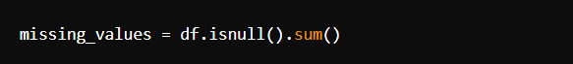

* **Imputation:** Once identified, missing values are addressed using interpolation or forward-fill methods to maintain data continuity. Forward-filling **(ffill)** propagates the last valid observation forward:

**Data Transformation**

* **Date Conversion:** The 'Start' and 'End' columns are converted to datetime objects for better handling of time-based data. This conversion enables more precise manipulation of dates and times:

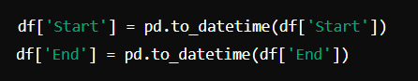

* **Dropping Unnecessary Columns:** Columns not relevant to the specific analysis are removed. In this case, columns such as 'Open', 'High', 'Low', 'Volume', and 'Market Cap' are dropped since only the 'Close' price is used for the model:



**Data Scaling**

* **Normalization:** Data scaling is performed to standardize the range of the 'Close' prices, which is crucial for neural network training. Min-Max Scaling rescales the data to a fixed range, typically [0,1], using the formula:

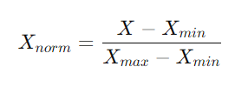

**Sequence Preparation**

* **Creating Sequences:** To get the information ready for LSTM model input, sequences of a fixed length **(base_days)** are created. Each sequence consists of historical 'Close' prices used to predict the next day's price:

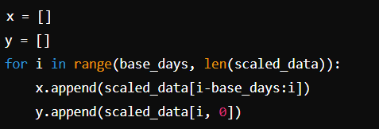

This approach captures temporal dependencies crucial for time series forecasting.

**Splitting Data**

* **Training and Testing Split:** The dataset is divided into training and testing sets. Typically, the last portion of the data is reserved for testing, allowing the model to be evaluated on unseen data:

train_data = scaled_data [: -500]

test_data = scaled_data [-500:]

**Data Validation**

* **Validation Checks:** Post-processing validation ensures data integrity. Checks are performed to confirm that there are no missing values and that there is enough data for training:

By implementing these preprocessing steps, the dataset is prepared effectively for training the LSTM model. This procedure guarantees that the data is clean, consistent, and scaled appropriately, which enhances the model's performance and accuracy.

**5.4. Exploratory Data Analysis:**

Exploratory Data Analysis (EDA) involves examining the dataset to summarize its main characteristics and uncover patterns, trends, and anomalies. In this project, EDA was performed on Bitcoin price data, focusing on the 'Close' price column. It included visualizing price trends

gradually employing line plots to Determine the seasonal trends. and significant fluctuations. Statistical summaries provided insights into the central tendency and dispersion of prices. study of correlations between several features helped understand their relationships. EDA also included identifying missing values and potential outliers, which informed subsequent data preprocessing steps to ensure the precision and dependability of the predictive model.

**5.4.1. Data Overview:**  
The project's dataset, designated BTC-2024, is an extensive compilation of past Bitcoin price data obtained from Yahoo Finance. Despite the fact that there are numerous variables in this dataset, our research primarily focusses on the 'Close' price. It has 5059 entries total that cover

a sizable chunk of the history of Bitcoin trading. A number of columns are included in the dataset, including "Start," "End," "Open," "High," "Low," "Close," "Volume," and "Market Cap." Only the 'Close' price is used for this project; the other columns offer further context.

There are no missing values in the 'Close' price column of the dataset, ensuring its completeness, which is essential for precise model training and prediction. The central tendency and volatility of Bitcoin prices can be understood by examining descriptive statistics, such as the mean, median, and standard deviation of the "Close" prices. Analysed using the date column, temporal patterns aid in the comprehension of past price changes and the identification of noteworthy trends. Cross-referencing the data with legitimate sources verifies its accuracy and ensures dependable input for the machine learning model utilised in this research.

**5.4.2. Data Visualization and Insights:**

**Dataset Overview:** To start, the dataset was analyzed using basic functions to understand its structure and summary statistics. The **describe()** function provided key statistical metrics, such as mean, median, standard deviation, and range for each column.

The output of **describe()** helped in understanding the central tendencies and dispersion of data values.

**Dataset Information:** A succinct synopsis of the dataset that includes the quantity of non-null entries and the data types of each column, was obtained using the **info()** function.   
Understanding the dataset's structure and locating any missing values required the knowledge in this section.

**Head and Shape of Dataset:** To obtain a feel for the format and content of the data, the **head()** method was employed to look into the first few rows of the dataset.   
The dataset's number of rows and columns was specified via the shape attribute. The quantity and organisation of the dataset were verified by these preliminary checks, which are essential for more in-depth examination.

**Closing Price Visualization:** A line plot of the 'Close' prices was created to visualize trends over time. This graph was essential for observing how Bitcoin's closing price has evolved and identifying significant trends and fluctuations.

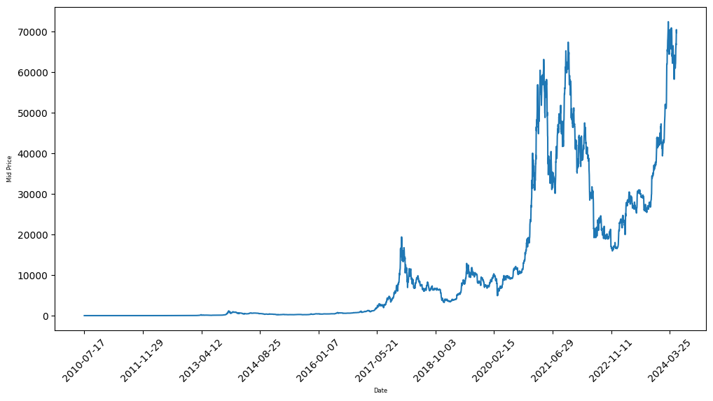

Figure 5.4.3: Data Visualization

The line plot illustrated the overall trend and notable variations in Bitcoin prices, which are important for making future predictions.

### Insights

* **Trend Analysis:** The line plot of closing prices highlighted key trends and fluctuations, such as periods of high volatility or steady growth.
* **Data Summary:** The **describe()**, **info()**, **head()**, and **shape()** functions provided a comprehensive overview of the dataset's statistical properties, structure, and content.

In this project, Exploratory Data Analysis (EDA) was conducted to understand the Bitcoin dataset. Key functions like describe() and info() provided statistical summaries and data structure insights, revealing metrics such as mean and standard deviation. The head() method offered a glimpse into the dataset’s initial rows, while `shape` confirmed its dimensions. A line plot of the 'Close' prices was generated to visualize price trends over time, highlighting significant fluctuations and patterns. This investigation offered crucial perceptions into data trends and variability, setting the stage for effective model development and future price predictions.

**6. METHODOLOGY**

**6.1. Data Analytics:**

In the **Data Analytics** phase of the Bitcoin price prediction project, several key techniques were employed. Exploratory Data Analysis (EDA) included using describe() for statistical summaries, info() for dataset overview, head() for initial data inspection, and shape to understand the dataset's dimensions. Visualization was achieved through a line graph of closing prices to identify trends and patterns. Statistical analysis, including correlation analysis, was conducted to understand relationships between features. Data cleaning involved handling missing values and outliers, while feature engineering created sequences of historical prices for model input. These steps ensured a comprehensive understanding of the data, essential for accurate predictions.

**6.2. Long Short-Term Memory (LSTM):**

A specific kind of recurrent neural network (RNN) called an LSTM network is made to handle data sequences and identify long-term dependencies within them. LSTMs help RNNs learn from and hold onto knowledge across extended sequences by resolving the problem of vanishing and exploding gradients that can arise in ordinary RNNs.

### Key Components:

1. **Cell State**: The cell state acts as a conveyor belt running through the LSTM units. It carries the long-term memory of the network, allowing information to be preserved over time. This component helps the network remember information from the distant past.
2. **Gates**: LSTMs use three types of gates to regulate the course of information:
   * **Forget Gate**: Decides which information from the cell state should be discarded. It uses a sigmoid activation function to output values between 0 and 1, where 0 means "completely forget" and 1 means "completely keep."
   * **Input Gate**: decides what fresh data needs to be added to the cell state. It combines a sigmoid activation function and a tanh activation function to update the cell state with new values.
   * **Output Gate**: Controls what information from the cell state should be output. It uses a sigmoid function to filter the cell state and a tanh function to scale the output values.

### Advantages:

* **Long-Term Dependencies**: By managing the cell state and gates, LSTMs can learn dependencies over long sequences, which is crucial for tasks like time series prediction or natural language processing.
* **Mitigates Vanishing Gradient Problem**: The cell state provides a way to preserve gradients over long sequences, helping the model to learn from long-term dependencies.

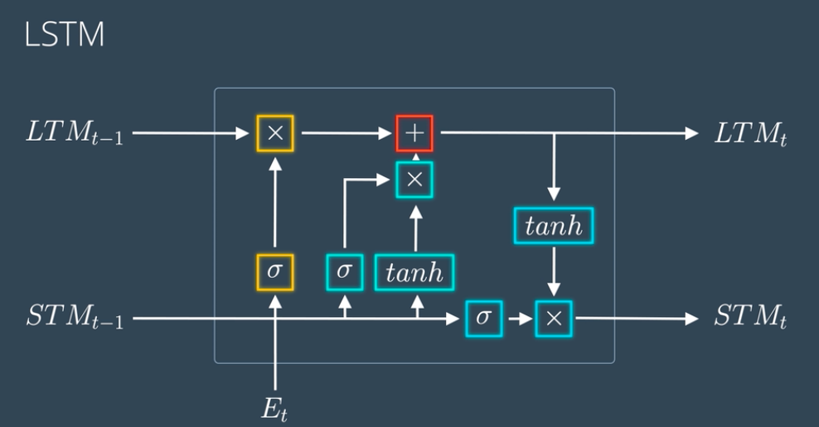

Figure 6.2.1: LSTM Architecture

**6.3. Model Details**

The model employs a series of LSTM layers to capture sequential patterns in Bitcoin's closing prices. It starts with an input layer, followed by multiple LSTM layers with ReLU activation and dropout for regularization. The final Dense layer outputs the predicted price, utilizing the learned temporal dependencies.

* **Input Layer**
  + **Purpose**: This layer specifies the input shape of the data. For this model, x.shape[1] represents the number of time steps in each sequence, and 1 represents the number
  + of features (in this case, just the closing price of Bitcoin). The Input layer initializes the model's input shape but does not perform any computations.
* **First LSTM Layer**
  + **Purpose**: This layer consists of 100 LSTM units. Each unit in the LSTM layer maintains its own internal state to recall details from earlier steps.
  + **Activation Function**: ReLU (Rectified Linear Unit) is used as the activation function here. Although LSTM layers traditionally use the tanh activation function internally, using ReLU as an activation function in some cases (like in this setup) can help in learning non-linear relationships.
  + **Return Sequences**: Setting return_sequences=True implies that this layer will return the full sequence of outputs for each input sequence, not just the final output. This is crucial as it allows the next LSTM layer to process sequences of outputs rather than just final time-step outputs.
* **Dropout Layer**
  + **Purpose**: Dropout is a regularization technique to prevent overfitting by randomly setting 20% among the input units for zero during training. This helps the model generalize better by reducing its reliance on any particular set of features.
* **Second LSTM Layer**
  + **Purpose**: Another LSTM layer with 100 units. Like the first LSTM layer, it returns sequences of outputs. As a result, the network can identify more intricate temporal patterns in the data as the sequences are passed through deeper layers.
* **Second Dropout Layer**
  + **Purpose**: This Dropout layer is applied after the second LSTM layer to further prevent overfitting and ensure that the model does not rely too heavily on any specific time step in the sequences**.**
* **Third LSTM Layer**
  + **Purpose**: The third LSTM layer, also with 100 units, continues to learn complex temporal dependencies. By returning sequences, it ensures that the entire output sequence is available for further layers to process.
* **Third Dropout Layer**
  + **Purpose**: Provides additional regularization to mitigate overfitting, applied to the outputs of the third LSTM layer.
* **Final LSTM Layer**
  + **Purpose**: After processing the complete sequence, the 120-unit final LSTM layer produces a single vector that summarises the sequence. This layer concentrates on removing the most pertinent features from the input data rather than returning sequences, in contrast to earlier LSTM layers.
* **Dense Output Layer**
  + **Purpose**: The Dense layer with a single unit produces the final output of the model. This layer applies a linear transformation to the output of the final LSTM layer to provide a scalar prediction (in this case, the predicted closing price of Bitcoin).

### 6.3.1. Mathematical Background

In LSTM networks, each unit's cell state (C) and hidden state (H) are updated through specific mathematical operations:

1. **Forget Gate**: Decides which information to discard from the cell state.



Where σ is the sigmoid activation function, ***Wf***are the weights for the forget gate, ***Ht−1*​** is the previous hidden state, and ***Xt*** is the current input.

1. **Input Gate**: Determines which values to update in the cell state.



* Updates the cell state:



* New cell state:



1. **Output Gate**: Determines the next hidden state.



* Output:



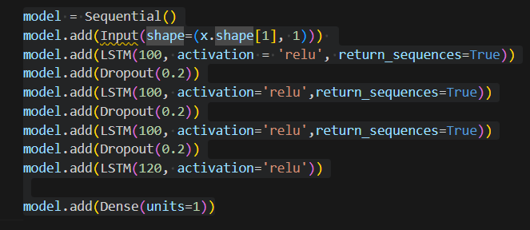

Figure 6.3.2: Project Model Code

**Model Summery**

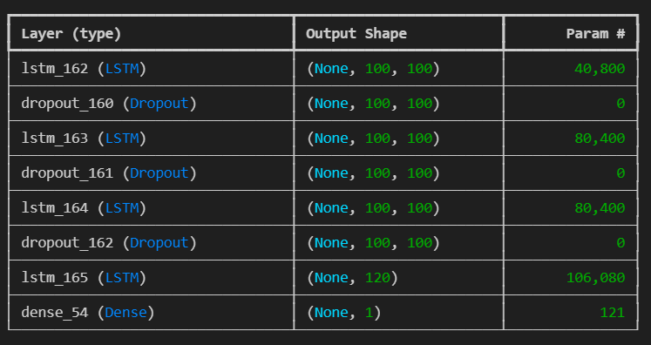

Figure 6.3.3: Model Summery

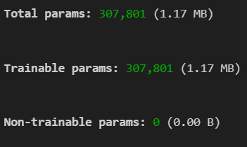

Model Summery 1

**6.4. Model Training and Compilation**

We employ the Adam optimiser, renowned for its effectiveness in managing big datasets and sparse gradients, to construct the model. Mean squared error (MSE) is the selected loss function because it works well for regression tasks like price prediction. To avoid overfitting, the EarlyStopping callback keeps an eye on the validation loss and stops training if no improvement is seen after ten epochs. Lastly, The training of the model is done by {verbose=1} for ten epochs using the fit technique.   
  
to offer thorough training process logs. With this configuration, the likelihood of overfitting is reduced and the model learns efficiently.

**6.4.2. Model Compilation**

#### Optimizer: Adam

The Adam (Adaptive Moment Estimation) optimizer is an extension of stochastic gradient descent that calculates each person's adaptive learning rate parameter. It combines the advantages of two other popular optimizers: AdaGrad and RMSProp.

Adam's update rule is given by:

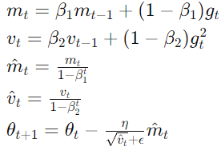

Here:

* *mt* and vt are the first and second moment estimates.
* β1​ and β2 ​ are the decay rates for these estimates.
* η is the learning rate.
* *gt ​* is the gradient at time step *t.*
* ϵ is a small constant to prevent division by zero.

#### Loss Function: Mean Squared Error (MSE)

MSE measures the average squared variation between the anticipated and actual values. It is defined as:



Where:

* *yi*​ is the actual value.
* *y^i*is the predicted value.
* *n* is the number of samples.

**6.4.2. Early Stopping**

EarlyStopping is a callback that stops training when a monitored metric has stopped improving. Here, it monitors the validation loss (val_loss) and stops training if it does not improve for 10 consecutive epochs (patience=10)

**6.4.3. Model Training**

The fit method trains the model for a fixed number of epochs on the provided dataset (x, y). The parameters are:

* epochs=10: how many times the network will process the complete training dataset.
* verbose=1: Provides progress bar and status updates during training.

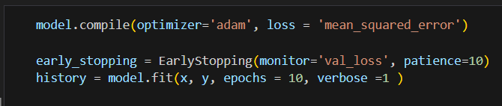

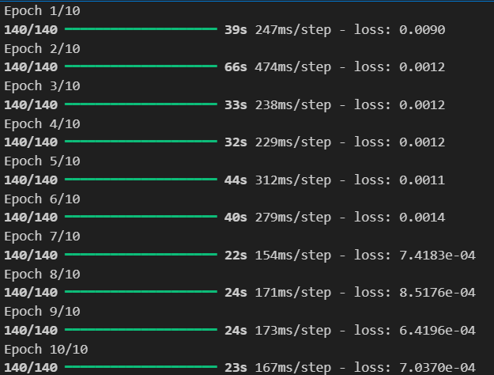

Figure 6.4.4: Model Training (Epochs Runs)

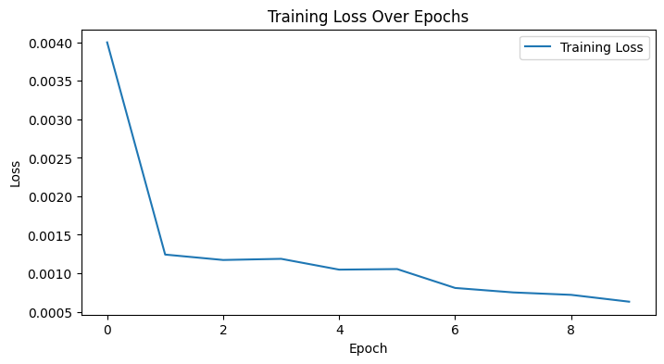

Figure 6.4.5: Training Loss over Epochs

**6.4.6. Prediction**

• **Input Data Preparation**:

* The input data x_test should be pre-processed in t In the same manner as the training data. This typically involves scaling and reshaping the data to match the input shape expected by the model.

• **Forward Propagation**:

* The predict method performs a forward pass through the network using the input data x_test.
* In each LSTM layer, the input sequence is processed step-by-step. Each LSTM cell updates its internal state and outputs based on the current input and the previous state.

• **Output**:

* The anticipated value for each input is the output obtained by the last Dense layer. sample in x_test.



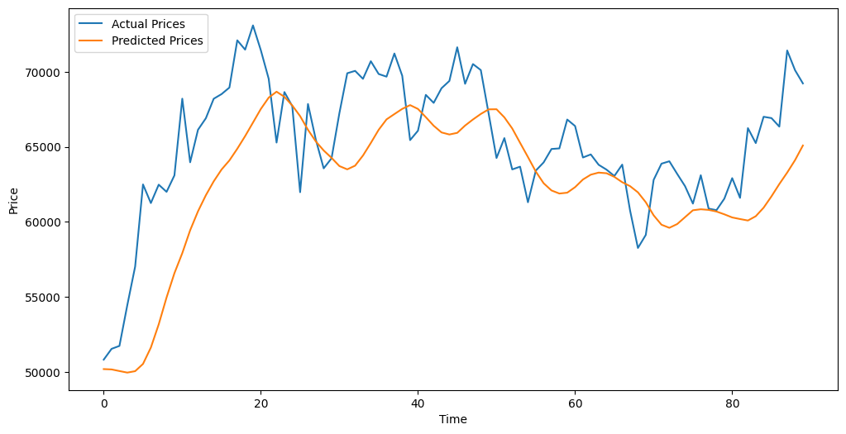

Figure 6.4.6: Actual VS predictions

1. **Model Evaluation (Mean Squared Error (MSE) and Mean Absolute Error (MAE))**

Once your LSTM model has produced predictions, it is critical to assess the model's accuracy and overall performance. MSE and MAE are two actions that are frequently employed for regression tasks.

#### Mean Squared Error (MSE)

The average squared difference between the actual and anticipated values is measured by MSE. In terms of squared error, it's helpful for determining how far off the forecasts are. Better prediction accuracy is shown by a lower MSE.



#### Mean Absolute Error (MAE)

MAE measures the average absolute difference between the actual and predicted values. It provides a straightforward interpretation of the average error magnitude.



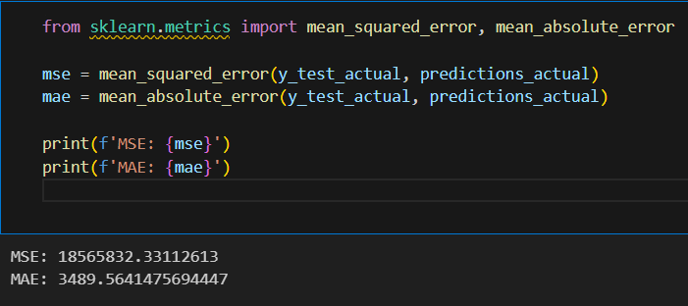

**7.1. Future Price Predictions with Model**

First, you define the number of future steps you want to predict (future_steps = 10) and initialize an empty list (future_predictions) to store the predicted values. The loop iterates for the specified number of future steps. In each iteration, the model generates a prediction based on the current last_sequence, and this prediction is appended to the future_predictions list.

After obtaining the prediction, it is reshaped to match the model's expected input shape of (1, 1, 1). This reshaping is crucial for ensuring that the prediction integrates properly with the existing sequence. The updated sequence is then created by concatenating the new prediction with the oldest data point removed. This process effectively shifts the sequence forward by one time step.

This approach continues for the number of future steps defined, with each new prediction updating the input sequence for the next iteration. As a result, future_predictions will contain the predicted values for the specified future time steps.

In summary, this code facilitates iterative forecasting by continuously updating the input sequence with newly predicted values, allowing the model to make predictions into the future based on the most recent data.

**7.2. Future Price Prediction**

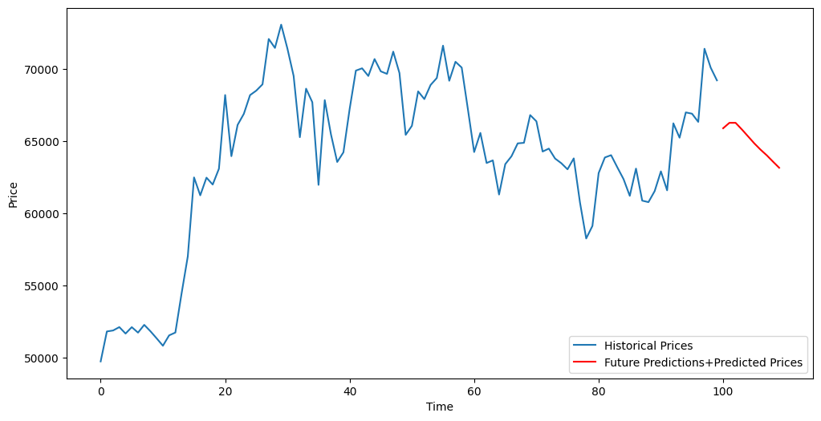

Figure 7.2: Future Prediction

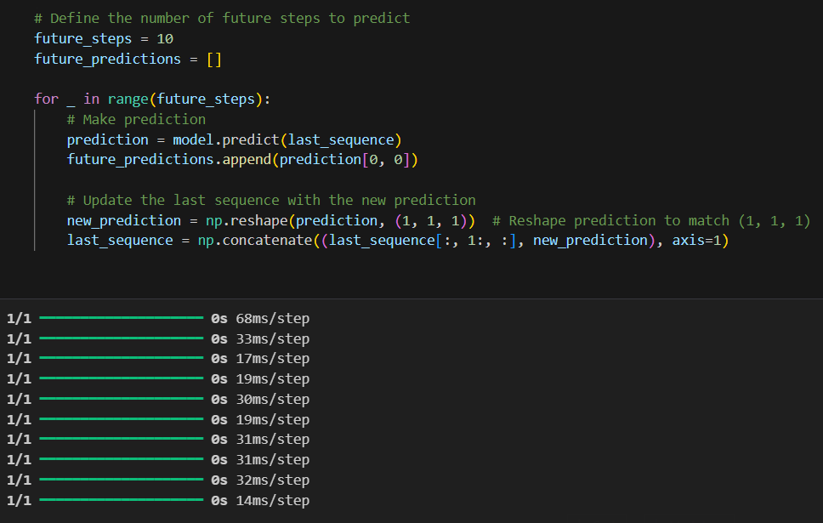

**7.3. Saving the Model**

The model.save('Bitcoin.keras') command is used to save your trained Keras model to a file named Bitcoin.keras. This file contains the architecture, weights, and training configuration of your model, which allows you to reload and use it later without having to retrain it.



**8. SYSTEM DESIGN**

**8.1. System Architecture:**

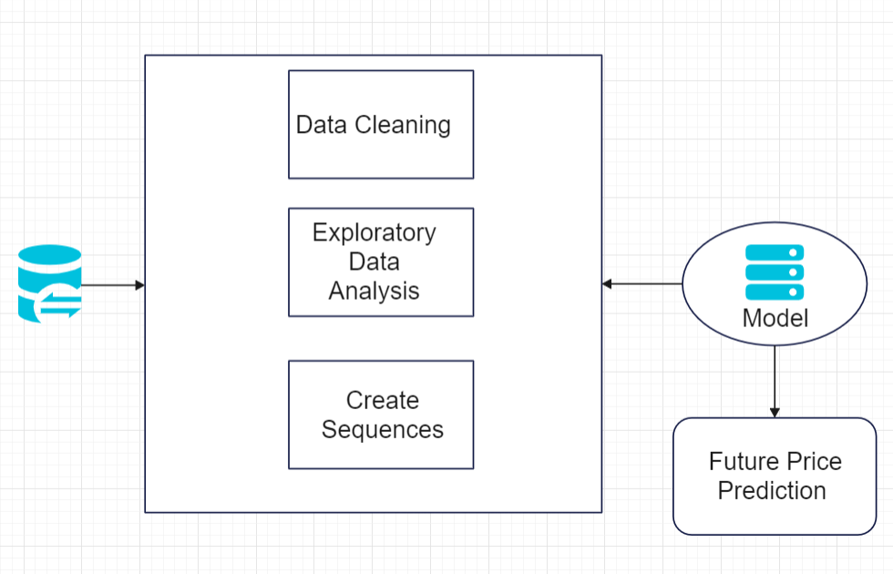

Figure 8.1: System Architecture

.

**7.2. Flow Chart:**

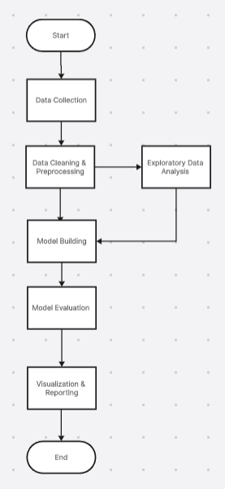

Figure 8.2: Flow Chart

* 1. **DEPLOYMENT AND STREAMLIT INTEGRATION**

**9.1. Deployment Overview:** The process of making a machine learning model usable is called deployment. in a production environment. It involves several steps including model saving, setting up an application or interface, and ensuring that the model can receive inputs and provide outputs effectively.

**Streamlit for Deployment:**

An open-source software framework for machine learning and data science projects is called Streamlit. Python scripts can be used to create interactive web apps. Because it can quickly convert Python code into a web application and requires little code, it's perfect for deploying machine learning models.

**Steps to Deploy with Streamlit:**

1. **Install Streamlit:** Ensure you have Streamlit installed. You can install it using pip

**pip install streamlit**

1. **Create a Streamlit App:** Write a Python script (app.py, for example) that uses Streamlit to create a web interface. You can load your saved model and create functionalities for users to interact with the model.
2. **Run the Streamlit App:** Navigate to the directory containing your app.py file and run:

**streamlit run app.py**

### 9.2. Virtual Deployment Using Git and Streamlit

**Streamlit** is a useful instrument for creating and deploying interactive web applications using Python. Integrating it with Git for virtual deployment involves several key steps:

1. **Code Management with Git:** Begin by setting up a Git repository for your Streamlit application. This repository will serve as the central hub for version control, allowing you

to keep track of modifications, work with others, and manage different versions of your codebase. Use platforms like GitHub or GitLab to host this repository.

1. **Developing the Streamlit Application:** Develop your Streamlit app locally by writing a Python script that utilizes the Streamlit library. This script will include loading, visualising, and other data-related components, and user interaction. Streamlit simplifies the creation of interactive dashboards and tools with minimal code.
2. **Version Control and Collaboration:** Commit your code regularly to the Git repository. This procedure guarantees that you have a record of changes and able to work well with other devs in collaboration. Using branches enables you to manage different features or stages of development.
3. **Continuous Integration/Continuous Deployment (CI/CD):** Set up CI/CD pipelines to automate the testing and deployment of your Streamlit app. This process involves configuring automated workflows that build and deploy your application whenever updates are made to the repository. CI/CD tools help streamline the deployment process and ensure that your application is still up-to-date.
4. **Deployment to Streamlit Sharing:** Deploy your submission utilising Streamlit Sharing, a platform that facilitates easy deployment from GitHub. By linking your GitHub repository to Streamlit Sharing, You are able to launch your application with a few clicks and obtain a public URL for access. Streamlit Sharing handles the hosting and scaling of your application.
5. **Monitoring and Updates:** After deployment, monitor the app’s performance and user interactions. Use Git for managing updates and improvements, making certain that any modifications are tracked and deployed efficiently through the CI/CD pipelines.

**10. OUTPUT SCREENSHOTS**

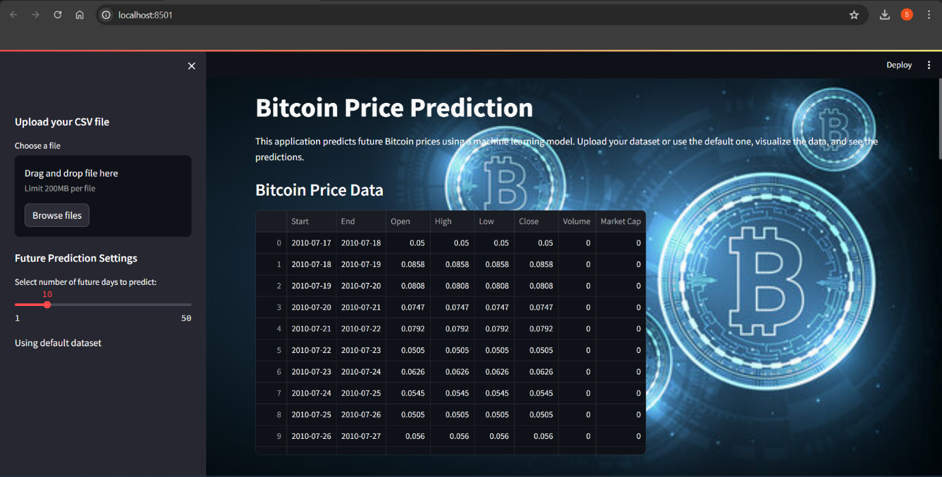

Figure 20.1: Output 1

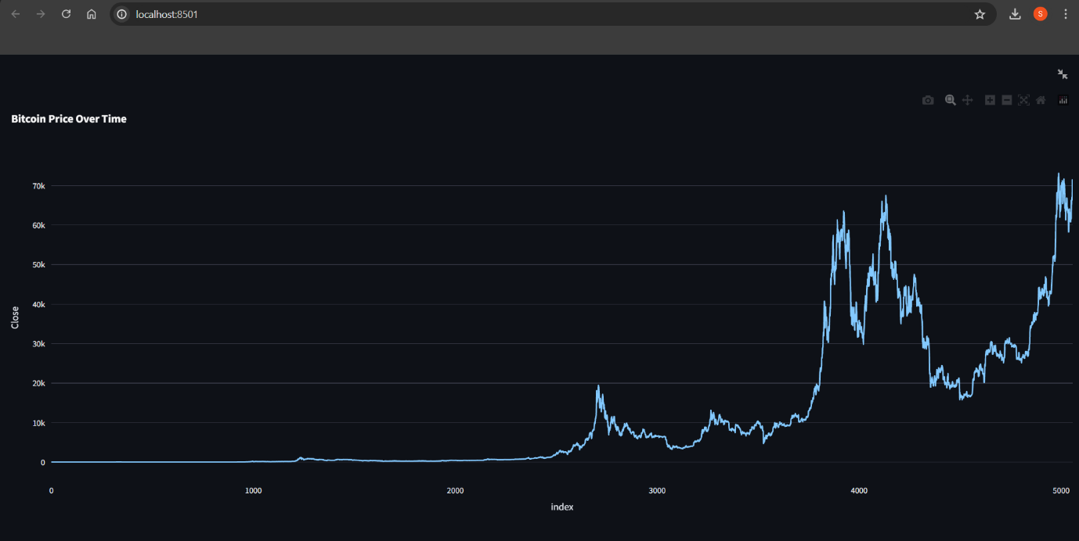

Figure 10.2: Output 2

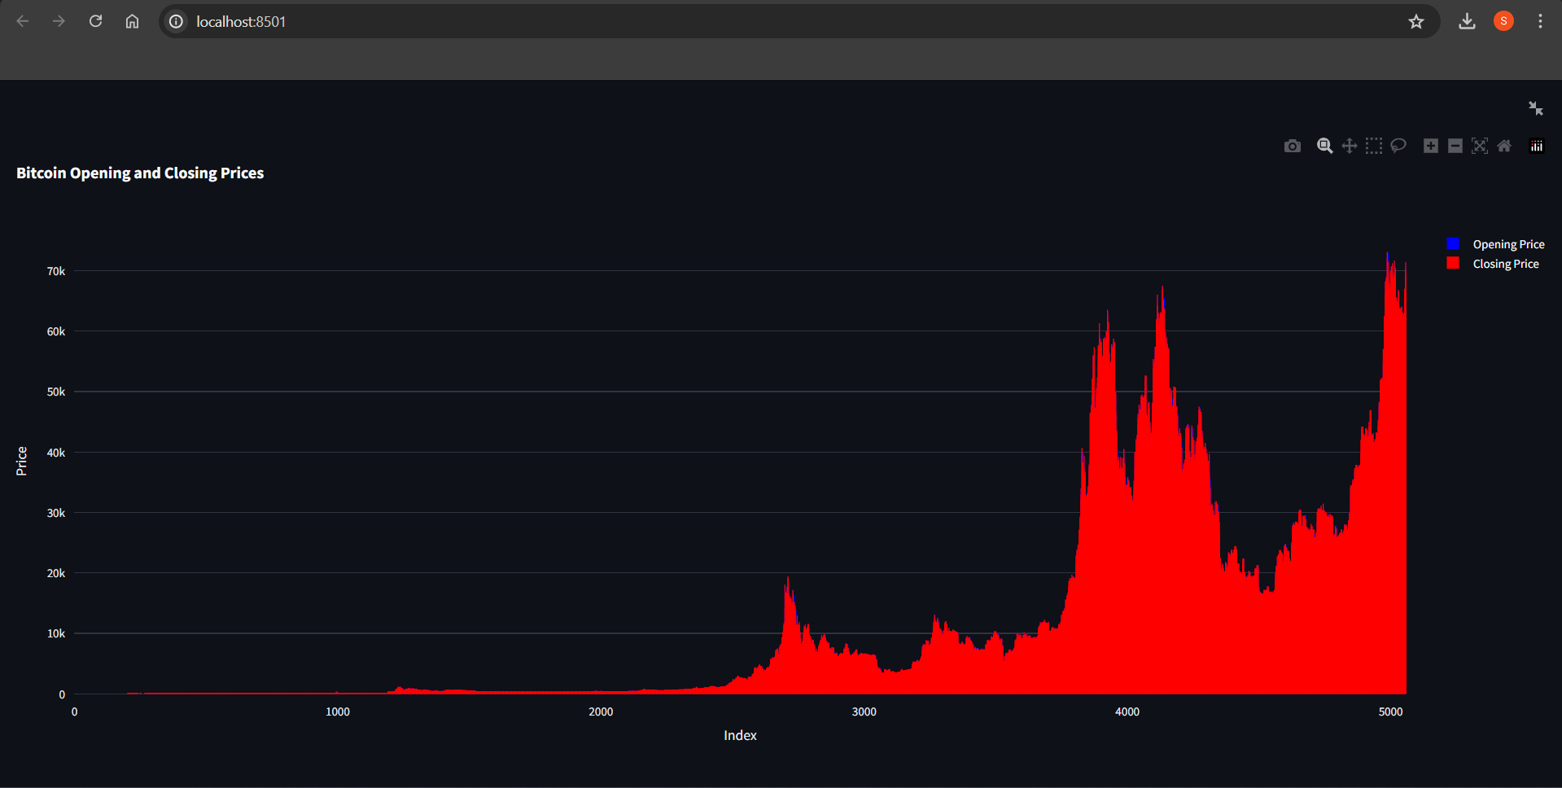

Figure 10.3: Output 3

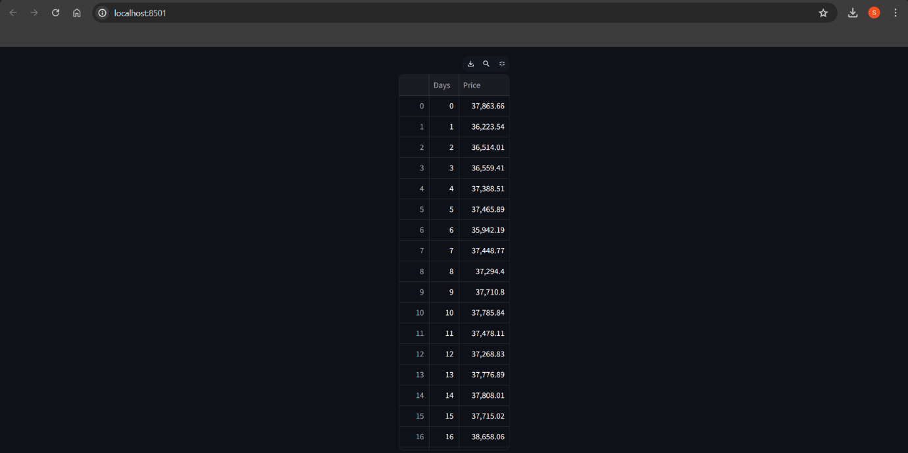

Figure 10.4: Output 4

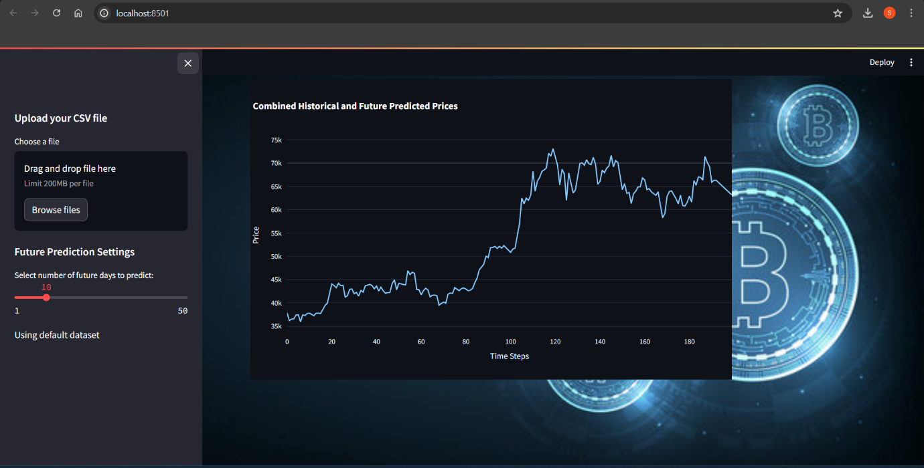

Figure 10.5: Output 5

**11. CONCLUSION**

The project aimed to develop an effective Model for predicting the price of bitcoin using machine learning, specifically employing Long Short-Term Memory (LSTM) networks. The process began with collecting historical Bitcoin price data from Yahoo Finance. This data was meticulously cleaned and pre-processed to handle missing values, scale features, and organize it for time-series forecasting. These actions were essential to getting the data ready for the LSTM model, which is designed to capture temporal dependencies in sequential data. The LSTM model, known for its ability to learn from sequential data, was built with multiple layers and dropout regularization to prevent overfitting. The Adam optimiser was used to optimise the model after it was trained using mean squared error as the loss function. To make sure the model generalised properly without overfitting, early halting was employed.

After training, the model's Mean Absolute Error (MAE) and Mean Squared Error (MSE) measures were used to assess performance. These evaluations confirmed the model's accuracy and effectiveness. Additionally, the model was used to make predictions about future Bitcoin prices, demonstrating its capability to forecast beyond the historical data.To make the model accessible and user-friendly, Streamlit was used to create an interactive application. This application permits users to upload their datasets, view historical and predicted Bitcoin prices, and explore future forecasts through an intuitive interface with interactive charts.

Overall, the project successfully combined LSTM networks with user-friendly visualization tools to create a powerful Bitcoin price prediction model. The Streamlit application makes this advanced forecasting tool accessible to a wider audience, including researchers and investors. The project’s success highlights the capabilities of artificial intelligence in financial analysis and suggests that further enhancements could be made by incorporating additional features or more advanced models to improve prediction accuracy.

**12. FUTURE ENHANCEMENT**

Future enhancements to this Bitcoin price prediction project can significantly elevate its accuracy and usability. One significant area that needs work is incorporating additional features beyond historical closing prices. Integrating When combined with macroeconomic data like inflation and interest rates, technical indicators like Bollinger Bands, Relative Strength Index (RSI), and moving averages can offer a more complete picture of market patterns and improve prediction accuracy. Exploring advanced modelling techniques could also improve performance. While the current LSTM model is effective, experimenting with Transformer-based models or hybrid approaches that combine LSTMs with Convolutional Neural Networks (CNNs) could offer better results. Additionally, refining data preprocessing methods—such as feature engineering and anomaly detection—can improve the quality of inputs to the model and help handle outliers more effectively.

Hyperparameter tuning and optimization are crucial for model performance. Employing systematic methods like grid search or Bayesian optimization to find the best hyperparameters, as well as using model assembling techniques, could enhance predictive accuracy. Integrating the model with live data feeds would make it more practical for real-time trading decisions, providing users with up-to-date predictions and insights based on current market conditions. Enhancing the user interface of the Streamlit application can also improve user experience. Features like interactive dashboards, customizable settings, and detailed analytics reports would offer a richer tool for financial analysis. Improved visualization options, such as comparing predictions with actual prices and providing historical performance metrics, would add value to the application.

Lastly, conducting thorough validation and robustness testing is essential. Implementing back testing strategies to Analyse the model's performance in different market scenarios. and using cross-validation techniques to evaluate its reliability across different data subsets will ensure that the model remains robust and trustworthy. By focusing on these enhancements, the

project can become a more advanced and practical tool for Bitcoin price prediction, benefiting users in the financial sector.

**APPENDIX A BIBILOGRAPHY**

1. Savage, James. (2020). Deficits and the Economy: The Case of the Clinton Administration and Interest Rates. 10.4324/9780429336232-7.
2. Lee, B.D., Cha, J.Y., Kim, M.R., Paek, N.C., Kim, W.Y. (2018). Photoperiod sensing system for timing of flowering in plants. BMB Rep., 51(4), 163-164. doi: 10.5483/bmbrep.2018.51.4.052.
3. Kaur, T., & Gandhi, T.K. (2019). Automated Brain Image Classification Based on VGG-16 and Transfer Learning. 2019 International Conference on Information Technology (ICIT), Bhubaneswar, India, pp. 94-98. doi: 10.1109/ICIT48102.2019.00023.
4. D.M. Daniel, M.L. Stone, B.E. Dobson, D.C. Fithian, D.J. Rossman, K.R. Kaufman. (1994). Fate of the ACL-injured patient: a prospective outcome study. Am. J. Sports Med., 22(5), 632-644.
5. T.W. Hash. (2013). Magnetic resonance imaging of the knee. Sports Health, 5(1), 78-107.
6. Hwang, S., Kim, H.-E., Jihoon Jeong, M.D., Kim, H.-J. (2016). A novel approach for tuberculosis screening based on deep convolutional neural networks. Medical Imaging 2016: Computer-Aided Diagnosis, vol. 9785, pp. 750-757. doi: 10.1117/12.2216198.
7. Islam, M.T., Aowal, M.A., Minhaz, A.T., Ashraf, K. (2017). Abnormality Detection and Localization in Chest x-rays Using Deep Convolutional Neural Networks.
8. F. Chollet. (2017). Deep Learning with Python. Manning Publications.
9. Hochreiter, S., & Schmidhuber, J. (1997). Long Short-Term Memory. Neural Computation, 9(8), 1735-1780. doi: 10.1162/neco.1997.9.8.1735.
10. Brownlee, J. (2018). Deep Learning for Time Series Forecasting. Machine Learning Mastery.
11. Goodfellow, I., Bengio, Y., & Courville, A. (2016). Deep Learning. MIT Press.
12. Ng, A.Y. (2004). Feature selection, L1 vs. L2 regularization, and rotational invariance. Proceedings of the twenty-first international conference on Machine learning, 78.
13. Kingma, D.P., & Ba, J. (2014). Adam: A Method for Stochastic Optimization. arXiv preprint arXiv:1412.6980.
14. Box, G.E.P., & Jenkins, G.M. (1976). Time Series Analysis: Forecasting and Control. Holden-Day.
15. Zhang, G.P. (2003). Time series forecasting using a hybrid ARIMA and neural network model. Neurocomputing, 50, 159-175. doi: 10.1016/S0925-2312(01)00702-0.

**APPENDIX B USER MANUAL**

**User Manual: Bitcoin Price Prediction Using LSTM**

1. **Introduction**

Welcome to the user manual for the "Bitcoin Price Prediction Using LSTM" application. This tool leverages sophisticated machine learning methods, particularly with regard to Long Short-Term Memory (LSTM) networks, to forecast future Bitcoin prices based on historical data. The application is

designed to offer insightful information to analysts and investors, aiding in informed decision-making and strategic planning.

1. **System Requirements**

**Hardware Requirements**

* **Processor:** AMD RYZEN 5 or Intel i5/i7/i9
* **Hard Disk:** 250 GB
* **Monitor:** 18" LED colour
* **Mouse:** Any
* **RAM:** 8GB and above

**Software Requirements**

* **Operating System:** Windows 7/8/10/11, Linux, or macOS
* **Programming Language:** Python 3.6+
* **Libraries:** TensorFlow, Keras, NumPy, Pandas, Plotly, Streamlit
* **IDE:** VS Code or PyCharm

1. **Installation**

**Step 1:** Install Python (Version 3.6 and above)  
**Step 2:** Set Up Virtual Environment

**Step 3:** Install Dependencies

1. **Running the Application**

To start the application, navigate to the project directory and run the main application script using Streamlit:

streamlit run main_app.py

1. **Using the Application**

**5.1. Uploading Data**  
**Step 1:** Open the application in your browser (the URL will be provided by Streamlit, typically <http://localhost:8501>).  
**Step 2:** Find and select the "Upload Data" section.  
**Step 3:** Click the "Browse" button and select the CSV file containing Bitcoin historical price data.  
**Step 4:** Ensure the data includes columns such as 'Date', 'Close', and other relevant fields.

**5.2. Making Predictions**  
**Step 1:** Navigate to the "Future Predictions" section.  
**Step 2:** Use the slider to select the number of future days you want to predict.

**Step 3:** Click the "Predict" button. The application will analyse the historical data and provide predictions for future Bitcoin prices.

**5.3. Viewing Results**  
**Step 1:** Navigate to the "Results" section.  
**Step 2:** View the predictions and visualizations, including historical price trends and future forecasts.

1. **Troubleshooting**

**Issue:** Application not starting  
**Solution:** Ensure you have activated the virtual environment and installed all dependencies.

**Issue:** Model predictions are not appearing  
**Solution:** Verify that the dataset is correctly formatted and the model has been trained properly.

**Issue:** Predictions are inaccurate  
**Solution:** Ensure the training set's history data is comprehensive and representative. Check if additional data preprocessing or model tuning is required.